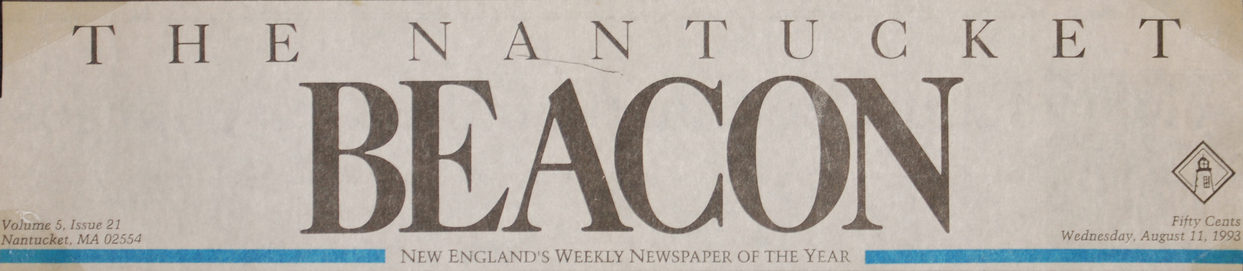

“Exploring thoughts and words as an art form”, Nantucket Beacon, 8/11/93

JOHN KEEGAN [Beacon staff writer]

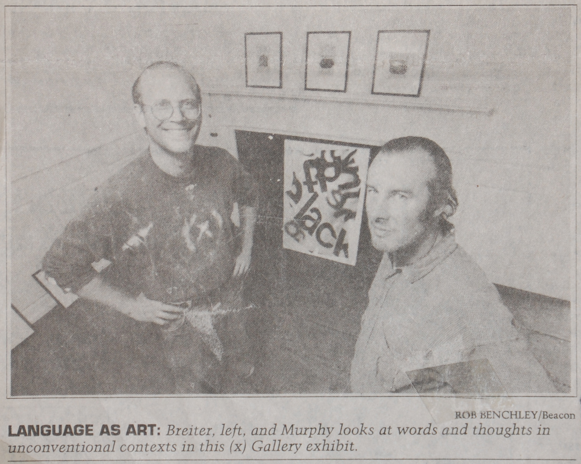

Hans Breiter’s “Boundary Conditions” and George Murphy’s “The Pictorial History” explore language and writing as art forms in an exhibit at the (x) Gallery.

Words are examined in unconventional contexts in this exhibit. Breiter’s work portrays “the physical nature of language,” he explains.

His media include painted words on canvas and two videos of human brains in action. Called functional magnetic resonance imaging, the videos show moment-by-moment changes in brain activity in a person during an extreme emotional experience, in this case when someone is obsessing.

The “affect” or emotion happens before we are aware it will occur, and is “essential to human discourse,” says Breiter, as a fundamental form of communication. This communication precedes our use of words, and underlies how we use them. By examining the words, we can examine how they carry emotion, conveying what is quintessentially human.
Breiter, a practicing psychiatrist, uses words from various individual psychotherapy and non-therapy conversations.
“The language templates utilized for these works deal with issues which many consider disturbing,” he says. “I consider these issues vital…These paintings are about people who have been raped, molested, beaten, abused, neglected and persecuted…These works look at their affect around these experiences in an attempt to see beyond the victimization and to see what is essentially human.”

Breiter’s background
Trained to draw super-realistically as a child by his art teacher mother, Breiter rebelled as a teen-ager to become a graffiti artist in Chicago. He later turned to use of found materials to render nudes, but since August, 1990 has “forgone the primary concern for the figure,” he says. He calls his new art form “process isolation art.”
This is Breiter’s second show at The (x) Gallery. His first show, October, 1990, also addressed difficult subjects. His “Suicide Triptych” contained words and colors to describe emotions in a way the figure couldn’t have.

Murphy’s work
At the same time as Hans Breiter’s (x) Gallery exhibit, artist George Murphy takes a look at words and illustration under glass in a show of his new works called, “The Pictorial History.”
Eighteen pages of text from an antique book The Pictorial History of the American Revolution, are isolation and “modified” with acrylic paint, Murphy says.
“The text becomes altered when you look at it in its modified form,” he says. “There’s an interesting tension between text and illustration usually. I’m creating a new tension within the illustration. I’m exploring literature as image.”
While the show involves a new medium for Murphy, it’s not a departure from his pattern of continually evolving art forms.
“I have a multiple creative personality,” Murphy jests. “There are certain aesthetic and non-aesthetic relations between them.”

◊ The two solo exhibits of works by Murphy and Breiter run simultaneously with a group show of works by members of The (x) Gallery through August 19.

